MY HOME GROUP DATA PARTNERSHIP, LP NEW LIMITED PARTNER JOINDER AGREEMENT
THIS NEW LIMITED PARTNER JOINDER AGREEMENT (“Agreement”) is made and entered into effective for all purposes and in all respects on the date of execution indicated below by My Home Group Data Partnership, LP, a Georgia limited partnership (“LP”) and (“NLP”) (collectively, the “parties”).
WHEREAS, LP was formed subject to that certain Limited Partnership Agreement dated April 17, 2019 among the general partner and the limited partners named therein (the “Partnership Agreement”) (capitalized terms used and not otherwise defined herein have the meanings given them in the Partnership Agreement);
WHEREAS, LP desires to gift a Limited Partnership Interest in LP to NLP; and
WHEREAS, NLP desires to accept a gift of Limited Partnership Interest and become a Limited Partner of LP subject to the terms and conditions contained herein.
NOW, THEREFORE, in consideration of the mutual promises, covenants, and conditions contained herein, the parties agree as follows:
- Purpose. The purpose of this agreement is to establish the terms and conditions upon which LP gives and NLP receives a limited partnership interest in LP.
- Acknowledgement of Gift. The parties hereby acknowledge that the issuance of the Limited Partnership Interest hereunder by LP to NLP is a gift, and that no money or economic benefit of any kind has or will be provided to LP in exchange for said gift. This gift is conditioned upon and subject to the terms of this Agreement.
- Limited Partnership Interest. Subject to the terms and conditions of this Agreement and the Partnership Agreement, herein incorporated by reference and included as EXHIBIT A to this Agreement, LP hereby gives to NLP a Limited Partnership Interest equal to the proportionate share attributable to NLP in accordance with the formula set forth in Section 15.01 of the Partnership Agreement and reflected in EXHIBIT A of the Partnership Agreement, as updated from time to time. This Limited Partnership Interest entitles NLP to participate as a Limited Partner in LP, with voting rights equal to NLP’s Limited Partnership Interest in LP.
- Adherence to Partnership Agreement. In accepting this Limited Partnership Interest, NLP hereby agrees (i) that NLP is a party to and bound by the Partnership Agreement, (ii) to take notice of, accept, and abide by the terms of the Partnership Agreement and (iii) to execute and deliver such additional agreements, instruments, certificates and documents as may be necessary, appropriate or convenient to reflect the foregoing matters and the election of LP. NLP hereby acknowledges that they have had an opportunity to review all terms of the Partnership Agreement and to receive advice from their independent legal counsel. NLP accepts this gift of a limited partnership interest freely and without reservation and fully supports the mission of LP, its interest in adding new partners which may dilute NLP’s own newly acquired interest/voting rights in LP, and all provisions of the Partnership Agreement.
- No Investment or Expectation of Profit. NLP affirms that NLP has not made an investment of money, capital, or other economic benefit of any kind to LP prior to or as consideration for acquiring the Limited Partnership Interest in LP. As NLP has not invested any money, capital, or other economic benefit of any kind to LP, NLP further acknowledges that NLP has no expectation of profit from NLP’s participation in LP as a Limited Partner. NLP affirms that NLP is prohibited from investing money, capital, or other economic benefit of any kind in LP.
- Not Securities.
  - NLP acknowledges that, due to the nature of acquisition of a limited partnership interest and the structure of LP, NLP’s Limited Partnership Interest is not a security and is not subject to federal or state securities laws. Furthermore, based on the terms of the Partnership Agreement, NLP acknowledges

that no interest in LP is a security interest and that all interests in LP are not subject to federal or state securities laws.
  - THE LIMITED PARTNERSHIP INTEREST REPRESENTED BY THIS AGREEMENT HAS NOT BEEN REGISTERED WITH THE SECURITIES AND EXCHANGE COMMISSION UNDER THE SECURITIES ACT OF 1933, AS AMENDED, OR QUALIFIED UNDER THE LAWS OF ANY STATE. SUCH INTEREST MAY NOT BE OFFERED FOR SALE, SOLD, DELIVERED AFTER SALE, TRANSFERRED, PLEDGED, OR HYPOTHECATED TO ANY PERSON IN THE ABSENCE OF AN OPINION OF COUNSEL SATISFACTORY TO THE GENERAL PARTNER THAT SUCH REGISTRATION OR QUALIFICATION IS NOT REQUIRED.
- Gift/Return Agreement. The parties acknowledge that a Gift/Return Agreement, hereby incorporated by reference and included in this Agreement as EXHIBIT B, has been simultaneously executed with this Agreement and that both documents must be executed for either to take effect.
- Effects. In accordance with the Partnership Agreement, LP shall amend the roster of Limited Partners to include NLP. To the extent the general partner of LP determines that it is in the best interest of LP to certificate its Partnership Interests, LP may provide NLP with a certificate reflecting NLP’s Limited Partnership Interest in LP.
- Miscellaneous Provisions.
  - Severability. Should any provision of this Agreement be declared or determined by any court of competent jurisdiction to be unenforceable for any reason, the validity of the remaining provisions of this Agreement shall not be affected thereby and the unenforceable provision shall be deemed not to be a part of this Agreement.
  - Entire Agreement; Waiver; Modification. This Agreement and the Partnership Agreement constitutes the entire agreement between the parties hereto with respect to the subject matter hereof and supersedes all other prior agreements and understandings, both written and oral, between the parties with respect to the subject matter hereof. No provision of this Agreement may be modified or waived except in writing signed by both parties.
  - Anti-Waiver. The failure of any party to enforce any of its rights arising by reason of any breach of covenant or failure of condition on the part of the other party will not constitute a waiver of such breach. No custom or practice arising between the parties in the course of administering the Agreement will be construed to waive any party’s right to: (i) insist upon the performance of the other party of any covenant or condition in the Agreement, or (ii) exercise any rights provided to it on the account of any breach of such covenant or failure of such condition.
  - Captions. Captions in this Agreement are inserted for convenience only and do not define, describe or limit the scope or the intent of this Agreement or form a part thereof.
  - Interpretation. The parties acknowledge this that each of them and their respective counsel have reviewed and approved this Agreement and that the normal rule of construction to the effect that any ambiguities are to be resolved against the party responsible for drafting the agreement shall not be applied in the interpretation of this Agreement. In entering into this Agreement each of the parties represents that it has relied upon the advice of counsel of its own choosing and that it has read in full and understood the terms of this Agreement and voluntarily accept the same.
  - Counterparts. This Agreement may be executed in two or more counterparts, each of which will be deemed an original, and all of which together will constitute one document. The exchange of a fully executed Agreement (in counterparts or otherwise) by electronic transmission in .PDF format or by facsimile shall be sufficient to bind the parties to the terms and conditions of this Agreement. A facsimile or scanned (e.g., .PDF, .GIF, etc.) signature shall be deemed to be an original.
  - Arbitration. Except as otherwise required by law, all disputes arising under or related to this Agreement (including, but not limited to, its revocability or voidability for any cause, the scope of arbitrable issues, and any defense based upon waiver, estoppel, or laches) shall be resolved by binding arbitration in Cobb County, Georgia before JAMS, or its successor, pursuant to the United States Arbitration Act, 9 U.S.C. § 1, by filing a written demand for arbitration with JAMS, with a copy to the other parties. The arbitration will be conducted in accordance with the provisions of JAMS’ Comprehensive Arbitration Rules

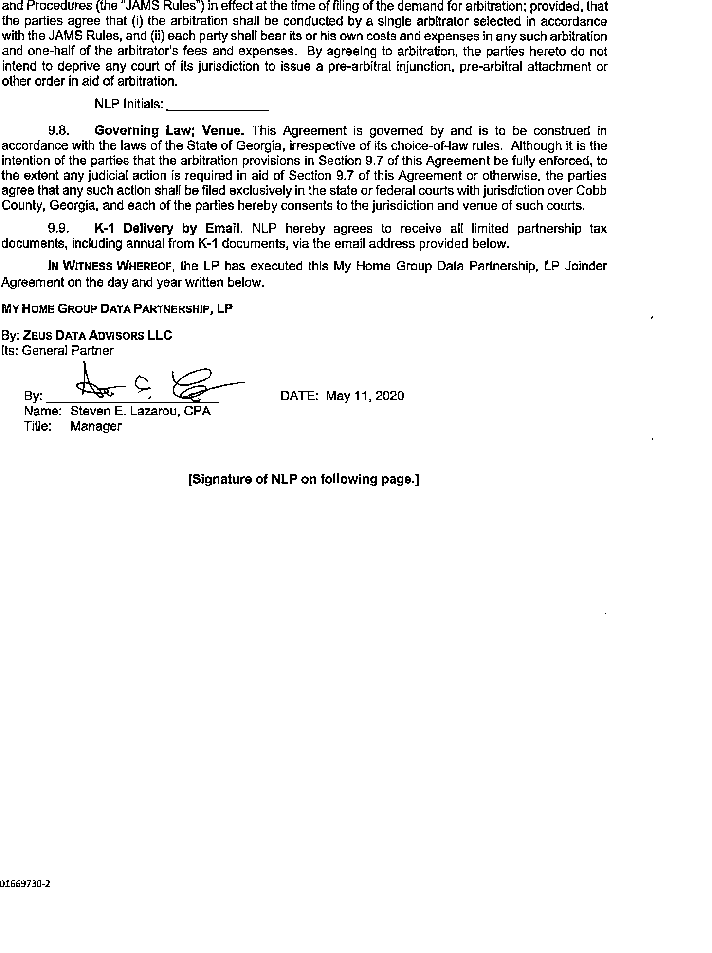

IN WITNESS WHEREOF, the NLP has executed this My Home Group Data Partnership, LP Joinder Agreement on the day and year written below.

NLP

By: Date:

NLP Email:

MY HOME GROUP DATA PARTNERSHIP, LP
GIFT/RETURN AGREEMENT
THIS GIFT/RETURN AGREEMENT (“Agreement”) is made and entered into effective for all purposes and in all respects on the date of execution indicated below by My Home Group Data Partnership, LP, a Georgia limited partnership (“LP”) and (“NLP” and, together with LP, the “parties”).
WHEREAS, the parties have entered into a New Limited Partner Joinder Agreement (to which this Agreement is an Exhibit) effective as of the date hereof (the “NLP Joinder”); capitalized terms used and not otherwise defined herein have the meanings given them in the NLP Joinder;
WHEREAS, LP desires to maintain a right to revoke the Limited Partnership Interest given to NLP (through the NLP Joinder) according to the terms of this Agreement; and
WHEREAS, NLP desires to maintain a right to return the gift of the Limited Partnership Interest given by LP according to the terms of this Agreement.
NOW, THEREFORE, in consideration of the mutual promises, covenants, and conditions contained herein, the parties agree as follows:
- Purpose. The purpose of this Agreement is to provide LP and NLP with terms and conditions regarding LP’s right to revoke NLP’s Limited Partnership Interest and NLP’s right to return its gift of a Limited Partnership Interest to LP.
- Revocation. The parties acknowledge that a nonprofit limited partnership interest in LP has no value and is worth $0. Therefore, NLP grants, and LP hereby maintains, upon thirty (30) days’ notice to NLP, a permanent option to revoke NLP’s Limited Partnership Interest.
- Return Policy. The parties acknowledge that NLP maintains the right, at any time upon thirty (30) days written notice to LP, to return to LP and disclaim NLP’s Limited Partnership Interest. LP agrees to accept such returns without objection.
- Effect of Buy Out or Return. Upon the effective date of either a revocation or a return of the Limited Partnership Interest as provided in Articles 2 or 3 hereof, as the case may be, NLP will no longer be a Limited Partner of LP. The terms of the Partnership Agreement, hereby incorporated by reference, will govern and control this procedure.
- Other Transfer Rules or Restrictions. The Partnership Agreement governs and controls all other transfers or prospective transfers of NLP’s Limited Partnership Interest.
- Miscellaneous Provisions.
  - Severability. Should any provision of this Agreement be declared or determined by any court of competent jurisdiction to be unenforceable for any reason, the validity of the remaining provisions of this Agreement shall not be affected thereby and the unenforceable provision shall be deemed not to be a part of this Agreement.
  - Entire Agreement; Waiver; Modification. This Agreement and the Partnership Agreement constitutes the entire agreement between the parties hereto with respect to the subject matter hereof and supersedes all other prior agreements and understandings, both written and oral, between the parties with respect to the subject matter hereof. No provision of this Agreement may be modified or waived except in writing signed by both parties.
  - Anti-Waiver. The failure of any party to enforce any of its rights arising by reason of any breach of covenant or failure of condition on the part of the other party will not constitute a waiver of such breach. No custom or practice arising between the parties in the course of administering the Agreement will be construed to waive any party’s right to: (i) insist upon the performance of the other party of any covenant or condition in the Agreement, or (ii) exercise any rights provided to it on the account of any breach of such covenant or failure of such condition.

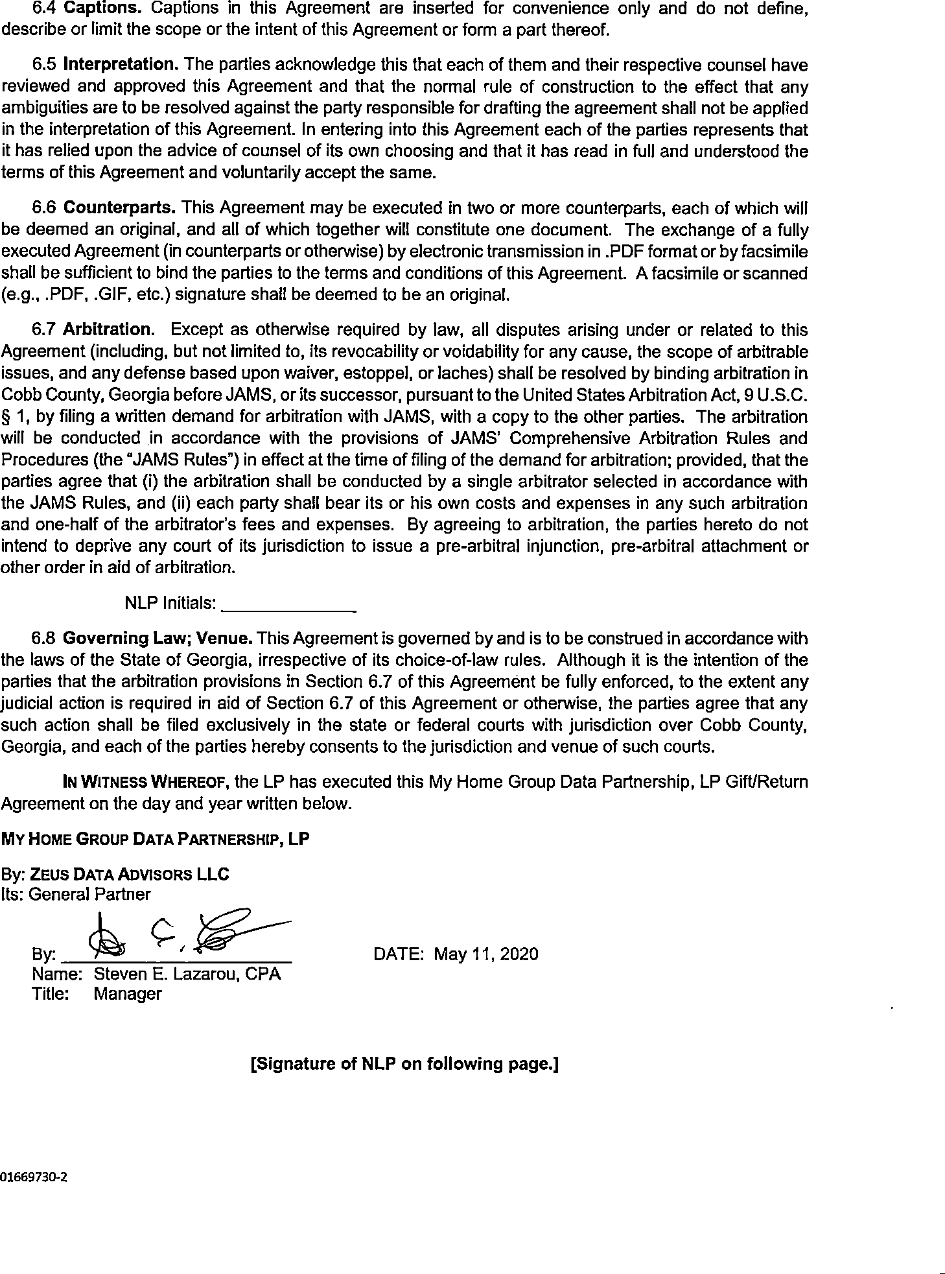

IN WITNESS WHEREOF, the NLP has executed this My Home Group Data Partnership, LP Gift/Return Agreement on the day and year written below.

NLP

By: Date:

01669730-2

